My Final Report: Goblin Co. Detector (GCD) Firmware Analysis

1. Project Overview
The goal was to implement B57AS Goblin Co. Detector (GCD) requirements using Arduino. I started off using the traditional arduino blocked framework but eventually restructured the code to a non-blocking state machine to prevent processor lockup during parallel NeoPixel, motor, and sensor operation.
I achieved this by:
- Using my custom schedule(t) helper function with millis(), allowing me to avoid the delay() function (except for the high-temp alert).[1]
  - This adds time to a scheduler for next action, functioning as a wait that enables parallel activity. Ill go into further depth in the Timing mechanism section.
- Delegating logic to dedicated update functions (updateBlink(), updateVibrate(), etc.) which are checked on every loop() cycle.[2]
- Tracking system condition using global state variables: vlevel, vcount, and vstate.
- For this all to function properly, I converted every (action > wait > action) loop into (conditional action > schedule future conditional action).
Main Components and circuitry
- Arduino UNO [3]
- Neopixel LED strip [4]
- Vibration motor [5]
- Potentiometer
- Temperature sensor [6]

The neopixel LED strip, vibration motor were not covered in our course and are therefore eligible for extra credit.

Figure one below is the circuit view and figure two is the wiring schematic.
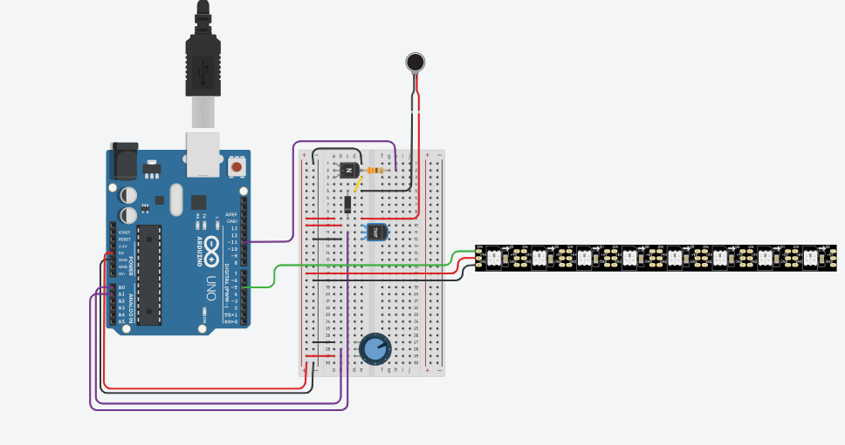
Figure 1

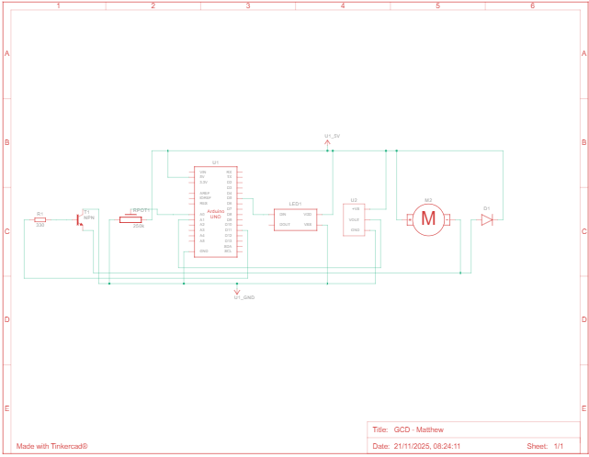
Figure 2

Key State Variables and Their Significance
Non-blocking architecture relies on global variables to maintain system "memory" between cycles:
Variable | Type | Significance in State Machine
nextvtime, nextBlinkTime | unsigned long | Core Timers: Store the specific future time (in milliseconds) when the motor or LED system is allowed to perform its next action.
vlevel | int | Vibration Input/Max Count: Stores the Goblin Class index (0-4), which dictates motor intensity and total required pulses.
vcount | int | Current Pulse Tracker: Tracks completed pulses in the current sequence. Critical for deciding when to stop and for Class 4 logic.
vstate | bool | Motor State Flag: A flag (true = ON, false = OFF) that ensures updateVibrate() alternates between turning the motor on and turning it off.
blinkspeed | int | Light Mode Selector: Stores the Goblin Class input. Drives updateBlink() logic, selecting the specific blink pattern and informing the timing formula.
blinkstate | bool | LED On/Off Flag: For standard blinking modes, this alternates between true (all lights ON) and false (all lights OFF) to create the blink effect.
larsonpos | int | Scanner Position: Tracks the current pixel index (0-7) of the leading edge of the Larson scanner effect.[4]

2. System Core: Setup and Heartbeat
The setup(), the loop(), and the schedule(t) helper form the non-blocking core.

System Initialization (setup())
The setup() function's sole role is initialization. It performs two key actions:
- Pin Mode Definition: Sets the motor pin to OUTPUT and the analog pins for the potentiometer and temperature sensor as INPUT.[3]
- Peripheral Startup: Initializes the NeoPixel strip, clearing any residual color.[4]

The Heartbeat (loop())
- Input Check: Reader() is called to process the potentiometer dial.
- Safety Check: tempcheck() is called to continuously monitor the temperature sensor.
- Output Update: The dedicated state handlers, updateVibrate() and updateBlink(), are called. These functions only execute their logic if the system time has passed their respective nextvtime or nextBlinkTime timers.[2]

Timing Mechanism (schedule(t))
Rather than using delay(t) (which halts the processor for t milliseconds), schedule(t) computes a future time (millis() + t) and stores it in the nextTime variable. This allows the processor to immediately move to the next task in the loop() while waiting for the timer to expire, ensuring parallel execution across all peripherals.[2]

3. Input Control
My primary control system relies on the analog potentiometer input, mapped to discrete Goblin Classes (0-4), which are then used as indices for the colour picker aswell as to inform blink speed and vibration time.
The Reader() function is the dedicated input handler. It continuously reads the potentiometer, applies the normalization formula, and compares the new Goblin Class (type) against the previous class (lastType).
- Normalization: The formula stage = floor(stage * 6 / 1023), maps 10-bit analog reading (0-1023) to integer values, representing the value as a fraction of 6, allowing representation for Goblin Classes 0-4.
- Stable State Change: Tracking static int lastType in Reader() ensures blink() and vibrate() are called only once per input change, eliminating jitter and unnecessary looping. These output functions are triggered only when the state changes.

4. Output Logic: LEDs and Haptic Feedback

LED Color Mapping Array
The LED behavior is underpinned by a static array that holds the color for each Goblin Class. This array, colors[5], stores pre-defined 32-bit color values (which encode Red, Green, and Blue). This structure ensures that the correct color is selected based on the input class index (blinkspeed or vlevel) with a single, fast array lookup. This was not covered in our course and is therefore eligible for extra credit[4]
Index (Class) | Color Name | R, G, B Value | Purpose
0 | Pink | (255, 20, 147) | Idle / Constant Light
1 | Green | (0, 255, 0) | Low Goblin Presence
2 | Yellow | (255, 255, 0) | Medium Goblin Presence
3 | Orange | (255, 50, 0) | High Goblin Presence
4 | Red | (255, 0, 0) | Critical Goblin Presence (Larson Scan)
This system completely decouples color selection from the complex timing logic found in the update functions, making the code more modular.

Complex LED Indicator Behavior
The blink() and updateBlink() functions generate four distinct lighting modes. I focused on direct input-to-behavior mapping, minimizing repetitive conditional logic.
- Class 4 (Larson Scanner) & Class 0 (Constant): These share the same core logic. For Class 4, I carefully controlled which pixels were lit and which were cleared (setcolour(None, larsonpos)) to generate a 3-pixel comet larson scanner effect, by implementing a conditional delay during the sequence of turning on all pixels. For Class 0, the logic finishes lighting all pixels and then maintains a constant state
- Classes 1–3 (Variable Blinking Speed): For Classes 1–3, I use a single formula for relative speed control based on the input index (goblin class):
  - The Inversion: I used the formula float time = (4 - blinkspeed) * k;
  - The blinkspeed index (1, 2, 3) required inverted delay times (Largest -> Smallest).
  - The section 4 - blinkspeed inverts the scale of blinkspeed, which is then multiplied by k giving a period coefficient that can be used to inform delay time.
  - Class 1 (Slowest) gives the largest time value (0.6).
  - Class 3 (Fastest) gives the smallest time value (0.2).
  - This eliminates complex if/else checks for the timing, making the code much more efficient.

State-Dependent Haptic Feedback

The updateVibrate() function generates complex pulse sequences, intensities, and durations using the goblin index.
- Intensity Formula: I customized the PWM range using int intensity = (vlevel * 100 / 4) + 155, This means the minimum intensity starts high (205), then adds up to define the required Low (205), Medium (230), and High (255) feedback levels.
- Safety Cleanup: I included the if (l < 2) { analogWrite(motorpin, LOW); } line in the vibrate() function to ensure the motor is immediately shut off when switching to a non-vibrating state (Class 0 or 1) which was a bug.

The Pulse Duration Formulas
I used two different formulae for pulse duration (speedk * timek) to meet varying pulse requirements:
Class | Specification | Formula Used | Design Rationale
2 & 3 | 2 Short / 3 Long | speedk = (((float)vlevel - 1) / 2.0) | Simple calculation based on vlevel to set a constant duration for all pulses in the cycle.
4 | 3 Short + 1 Long | speedk = (float)clamp(vcount - 1) / 2.0 | The State-Dependent Hack: Pulse duration changes mid-cycle by making speedk dependent on the current pulse count (vcount) instead of the fixed vlevel.
Class 4 logic is the most complex, combining my custom clamp() function with vcount to achieve the required pattern:
Pulse | vcount | clamp(vcount - 1) | speedk | Result
1st | 0 | 1 | 0.5 | Short
2nd | 1 | 1 | 0.5 | Short
3rd | 2 | 1 | 0.5 | Short
4th | 3 | 2 | 1.0 | Long
This confirms the code matches the "3 short pulses then 1 long pulse" requirement using exclusively formulae.

5. High-Temperature Safety System
The tempcheck() function is a complete safety module:
- It accurately performs voltage and temperature conversions using the formula temp = (volt - 0.5) * 100.[6]
- It uses the hightemp state variable to trigger the required sequence—flash magenta five times—only once when the 40°C threshold is crossed, providing a safety alert.

6. Summary
The GCD firmware meets every Specification. I'm proud of how the custom formulas in blink and vibrate translated simple inputs into complex, precise hardware behaviors.

References (Harvard Style)
- Adafruit Industries (n.d.) NeoPixel Überguide. Available at: https://learn.adafruit.com/adafruit-neopixel-uberguide (Accessed: 21 November 2025).
- Analog Devices (n.d.) TMP36 temperature sensor datasheet. Available at: https://www.analog.com/media/en/technical-documentation/data-sheets/TMP35_36_37.pdf (Accessed: 21 November 2025).
- Arduino (n.d.) Arduino Uno technical specifications. Available at: https://www.arduino.cc/ (Accessed: 21 November 2025).
- Arduino (n.d.) Analog input – documentation. Available at: https://docs.arduino.cc/ (Accessed: 21 November 2025).
- Arduino (n.d.) Blink Without Delay example. Available at: https://docs.arduino.cc/built-in-examples/digital/BlinkWithoutDelay/ (Accessed: 21 November 2025).
- Microchip Technology (n.d.) State machines in embedded systems. Available at: https://www.microchip.com/en-us/technologies/microcontrollers (Accessed: 21 November 2025).

